**Results and Discussion**

**Microbiome Composition at Baseline**

Initial microbiome profiles varied between individuals but exhibited consistent trends within health categories (Figure 1). Healthy microbiomes (K3, K10) were dominated by *Bacteroidaceae*, *Lachnospiraceae*, *Ruminococcaceae*, and *Enterobacteriaceae*, consistent with typical human gut microbiota. In contrast, disease-associated microbiomes were disproportionately enriched in *Prevotellaceae*, which made up over 50% of the community. This baseline compositional divergence provides critical context for interpreting treatment-induced changes.

**Microbiome Shifts During Fermentation**

After 16 hours of in vitro fermentation, pronounced shifts in microbial community composition were observed across all samples (Figure 2). Beta diversity analysis using four distance metrics revealed clear and reproducible trajectories of microbial change, with healthy and disease-associated microbiomes clustering by group. These directional changes suggest that despite individual variation, microbiomes exhibit consistent patterns in response to prebiotic substrates.

**Treatment-Specific Effects on Healthy Microbiomes**

Focusing on healthy microbiomes, distinct patterns of response emerged across treatment categories (Figure 3). Oligosaccharides and gums tended to induce similar compositional changes, while β-glucan and waste stream-derived treatments produced more divergent shifts. At the individual level, certain treatments—such as pomegranate powder and micronized cassava fiber—induced markedly different beta diversity changes compared to other samples. These findings highlight the differential fermentability and microbiome-modulating potential of specific dietary fibers and botanicals.

Quantification of compositional shifts confirmed these trends (Figure 4). Treatments like Betavia Pure WD, cellulose, ginger powder, HiSmooth flax seed fiber, mushroom chitosan, olive flour, pomegranate powder, psyllium husk, and xanthan gum consistently elicited greater beta diversity distances from baseline. These results support the hypothesis that certain dietary components exert stronger microbiota-modulating effects than others.

**Dose–Response Relationships**

Dose–response analysis revealed complex and sometimes microbiome-specific patterns (Figure 5). HiSmooth flax seed fiber and guar gum consistently induced stronger microbial shifts at lower doses, displaying an inverse relationship across all four microbiomes. In contrast, ground beet pulp exhibited a positive dose–response in the K5 microbiome but an inverse relationship in others, underscoring the importance of host-specific factors in shaping prebiotic effects.

**Taxonomic and Functional Shifts**

PERMANOVA-based differential abundance analysis revealed clear taxonomic restructuring across treatments (Figure 6). β-glucan treatments consistently reduced the abundance of genera such as *Faecalibacterium*, *Lachnoclostridium*, and *Peptoclostridium*, while increasing *Extibacter* and *Clostridium*. Notably, treatment clustering did not always align with category labels. For example, a subset of botanicals (e.g., pomegranate, carrot, beetroot, spinach, lemon, and olive flour) clustered with micronized cassava fiber and beet pulp rather than other botanicals, suggesting overlapping functional effects on microbial communities.

**Targeted Effects on Key Genera**

Focused dose–response analysis in microbiome K3 identified treatments with opposing effects on *Faecalibacterium*, a key anti-inflammatory taxon (Figure 7). Samples such as BetaVia Pure WD, ginger powder, cellulose, and micronized cassava fiber increased *Faecalibacterium* abundance in a dose-dependent manner. Conversely, ground beet pulp, dried apple pomace, and lemon powder reduced its abundance at higher concentrations. These patterns align with broader taxonomic trends observed across microbiomes (Figure 8). For instance, *Fusobacterium*—a genus often associated with gut dysbiosis—was consistently reduced by increasing doses of gums, cassava fiber, and ginger powder. Meanwhile, *Blautia* and *Lachnospiraceae UCG-010* were negatively affected by many botanicals and fiber treatments.

**Prebiotic Potential Across Treatments**

To integrate these findings, a Prebiotic Potential Index (PPIa) was calculated based on the relative abundance of beneficial versus harmful taxa (Table 1). All treatments demonstrated some degree of positive modulation, with micronized cassava fiber yielding the highest PPIa. This suggests its potential as a particularly effective dietary intervention for promoting gut health, although the differences between treatments were modest overall.

**Summary and Implications**

Together, these findings illustrate that prebiotic effects are both treatment- and host-dependent. While certain substrate classes (e.g., gums, β-glucans) exhibit predictable impacts, individual treatments such as micronized cassava fiber and pomegranate powder stand out for their unique and potentially beneficial effects on the gut microbiota. The dose–response data further reveal that effective modulation of the gut microbiome may require personalized dosing strategies. The consistent reduction of *Fusobacterium* and support of *Faecalibacterium* by specific treatments point to promising avenues for targeted microbiome interventions aimed at restoring or maintaining gut health.

**Figures and Tables**

**Figure 1.** **Relative abundance profile of microbial families across four different human microbiomes.** FBB0 represents the fecal buffer blank at time 0, while FBB16 corresponds to the buffer after 16 hours of fermentation. Although baseline microbiome compositions vary among individuals, healthy microbiomes (K3, K10) show similar relative abundance patterns, predominantly comprising *Bacteroidaceae*, *Enterobacteriaceae*, *Fusobacteriaceae*, *Lachnospiraceae*, and *Ruminococcaceae*  . In contrast, disease-associated microbiomes are markedly enriched in *Prevotellaceae*, which accounts for more than half of the microbial community.

(A)

**Figure 2.** **Microbiome compositional shifts after 16 hours of fermentation, visualized by (A) category and (B) individual sample.** Beta diversity was calculated using four distance metrics: Bray–Curtis, Jaccard, unweighted UniFrac, and weighted UniFrac. Principal component analysis (PCA) was performed on each distance matrix, and the first two principal components were used for visualization. Arrows indicate the trajectory of microbiome shifts from the initial state (FBB0) to post-fermentation states across different categories. Across all distance metrics, healthy microbiomes exhibit similar directional changes, as do disease-associated microbiomes.

(A)

(B)

Figure 3. **Beta diversity changes in healthy microbiomes from the initial state (FBB0) to post-treatment states, shown at the level of (A) treatment categories and (B) individual samples.** (A) Treatments with oligosaccharides and gums induce similar shifts in microbiome composition, whereas β-glucan and waste stream treatments result in the most distinct changes. (B) Most individual samples produce comparable effects on the microbiome; however, pomegranate powder and micronized cassava fiber cause notably distinct shifts relative to others. A graph of different colored and black lines

Figure 4. **Box plots showing the beta diversity distances between each sample treatment and the corresponding FBB0 baseline for each microbiome.** Consistent patterns and trends are observed across all four microbiomes. Several treatments—including Betavia Pure WD, cellulose, ginger powder, HiSmooth flax seed fiber, mushroom chitosan, olive flour, pomegranate powder, psyllium husk, and xanthan gum—exhibit relatively greater shifts from the baseline compared to other samples.

Figure 5. **Dose–response relationships between treatment amount and beta diversity shift from FBB0 in microbiomes (A) K3, (B) K5, (C) K7, and (D) K10.** HiSmooth flax seed fiber and guar gum consistently exhibit a negative dose–response relationship across all four microbiomes. While most treatments display microbiome-specific responses to increasing doses, an interesting pattern is observed for ground beet pulp: it shows a positive dose–response relationship in the K5 microbiome but a negative relationship in K3, K7, and K10.

Figure 6. **Heatmap of differentially abundant genera identified by PERMANOVA across sample groups.** A Permutational Multivariate Analysis of Variance (PERMANOVA) was performed to identify genera with significantly different abundances across treatment groups. Log10 transformed abundance ratios were calculated for each genus, and the results were visualized as a heatmap. Warmer colors indicate higher relative abundance. Taxa are organized based on co-occurrence patterns, while samples are clustered according to similarity in microbial community composition. Samples from the same category often exhibit similar effects on microbiome structure. For example, β-glucan samples (Oat Bagasse Hydrolysate-B, Oat Bagasse Hydrolysate-PBV, and Oat Bagasse-Control) cluster together, showing consistent effects—namely, a reduction in the abundance of *Faecalibacterium, Lachnoclostridium, Peptoclostridium, Tyzzerella, and [Ruminococcus] gauvreauii group*, alongside an increase in *Extibacter* and *Clostridium*. Interestingly, samples from different category groups can show more similarity to each other than to samples within their own category. A notable example is a mixed group—including pomegranate powder, carrot powder, beetroot powder, dried spinach powder, lemon powder, and olive flour (from the Botanicals category)—which clusters with micronized cassava fiber, ground beet pulp, and dried apple pulp, rather than with other Botanicals. This combined group is characterized by a distinct pattern: decreased abundance of *Lachnoclostridium, Megamonas, Blautia, and Clostridium,* and increased abundance of *Tyzzerella*.

Figure 7. **Dose–response effects of 23 samples on *Faecalibacterium* abundance in microbiome K3.** Each sample was tested at four different dose levels (5 mg, 10 mg, 15 mg, and 20 mg), and their effects on the relative abundance of *Faecalibacterium* were plotted. BetaVia Pure WD, ginger powder, cellulose, and micronized cassava fiber showed a clear positive dose–response relationship, increasing *Faecalibacterium* abundance with higher doses. In contrast, ground beet pulp, dried apple pomace, and lemon powder exhibited a negative relationship, with higher doses leading to decreased abundance. *Faecalibacterium* is a commonly present and beneficial gut bacterium, often associated with anti-inflammatory effects and overall gut health. Dose–response effects on other beneficial and potentially harmful genera across different microbiomes are presented in the Supplementary Figures.

1. (B)

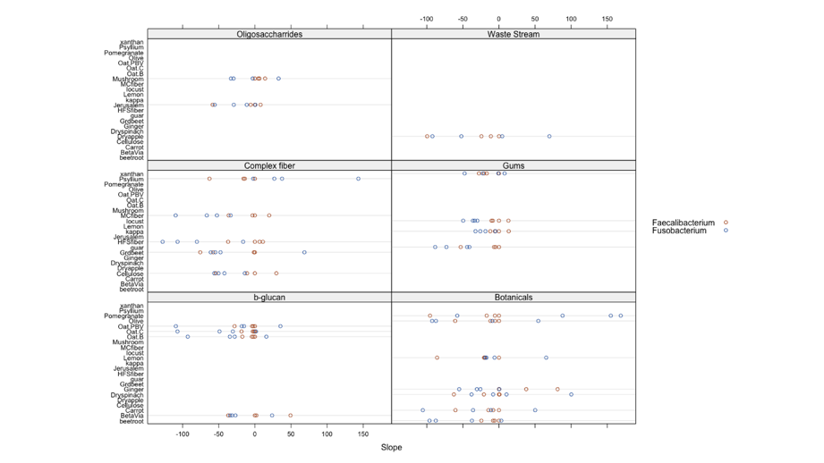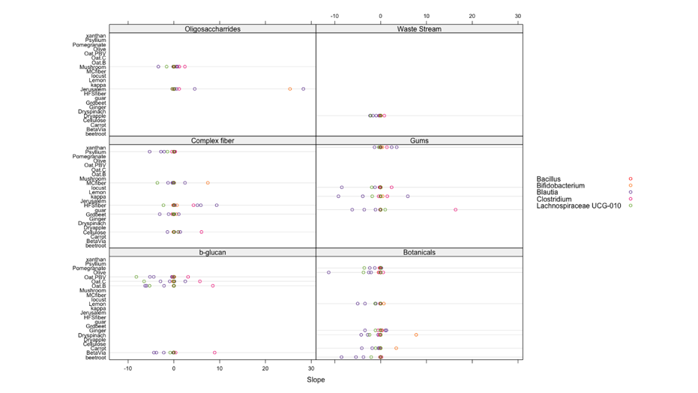

Figure 8. **Dose-dependent microbial responses to various samples: differential effects on *Fusobacterium, Faecalibacterium, Bacillus, Bifidobacterium, Blautia, Clostridium*, and *Lachnospiraceae UCG-010*.** Dose–response slopes were calculated for each taxon based on relative abundance changes across increasing sample concentrations. Due to the relatively large slope magnitudes for *Faecalibacterium* and *Fusobacterium*, results are displayed in two separate panels. Positive slope values indicate a positive correlation between sample dose and taxon abundance, while negative values indicate an inverse relationship. Each data point represents the slope from one of four microbiome replicates per sample type. In Figure 8A, *Fusobacterium* shows a consistent negative dose–response across all four microbiomes for treatments such as micronized cassava fiber (MC fiber), HiSmooth flax seed fiber (HFS fiber), locust bean gum, kappa carrageenan, guar gum, ginger powder, and beetroot powder. The β-glucan treatments (Oat PBV, Oat Control, and Oat B) also negatively impact *Fusobacterium* abundance in three out of four microbiomes. For *Faecalibacterium*, increasing doses of β-glucan, waste stream, most gums, and most botanicals generally lead to reduced abundance. In Figure 8B, *Blautia* tends to be negatively affected by gums, botanicals, and β-glucan, while *Clostridium* exhibits a positive dose–response relationship with β-glucan treatments.



**Table 1.** Classification of genera as beneficial or harmful was based on previous research (see Supplementary Materials). Read counts were summed separately for beneficial and harmful taxa, and the **Prebiotic Potential Index (PPIa)** was calculated using the following formula:  
**PPIₐ = (Reads mapped to beneficial taxa – Reads mapped to harmful taxa) / Total reads.**A higher PPIa value indicates a greater potential for promoting a healthy gut microbiome. Overall, all treatments showed comparable beneficial effects. Among them, **micronized cassava fiber**exhibited a slightly higher PPIa, suggesting a marginally stronger positive impact on gut microbial health relative to other samples.